**B.M.S. College of Engineering**

(Autonomous College Affiliated to Visvesvaraya Technological University, Belgaum)

Bull Temple Road, Basavanagudi, Bengaluru – 560019



**Department of**

# Computer Science & Engineering (CSE)

**Lab Programs Report**

**Course Title: Object Oriented Java**

**Programming**

**Course Code: 23CS3PCOOJ**

**BY**

# Gurrala Naga Pragnathmik (1BM22CS103)

**B.M.S. College of Engineering**

(Autonomous College Affiliated to Visvesvaraya Technological University, Belgaum)

Bull Temple Road, Basavanagudi, Bengaluru – 560019



**Department of**

**Computer Science & Engineering (CSE)**

# *CERTIFICATE*

This is to certify that the report on “**Java Lab Programs**” has been carried out by **Gurrala Naga Pragnathmik** bearing USN **1BM22CS103** as a part of AAT for the course **Object Oriented Java Programming** with course code **23CS3PCOOJ**,

Computer Science and Engineering from Visvesvaraya Technological University, Belgaum during the year 2023–24. It is certified that all corrections/suggestions indicated for Internal Assessments have been incorporated in the report.

|  |  |
| --- | --- |
| **Gurrala Naga Pragnathmik** | **Shravya AR** |
| 1BM22CS103 | Assistant Professor |

Department of CSE

**Table of contents**

|  |  |  |
| --- | --- | --- |
| **S. No.** | **Title** | **Pg**  **No.** |
| 1. | **Lab Program 1** | 3-5 |
| 2. | **Lab Program 2** | 5-7 |
| 3. | **Lab Program 3** | 8-11 |
| 4. | **Lab Program 4** | 12-14 |
| 5. | **Lab Program 5** | 15-19 |
| 6. | **Lab Program 6** | 20-23 |
| 7. | **Lab Program 7** | 24-26 |
| 8. | **Lab Program 8** | 26-28 |

## LAB PROGRAM 1

Develop a Java program to create a class Student with members usn, name, an array credits and an array marks. Include methods to accept and display details and a method to calculate percentage of a student.

**CODE**import java.util.Scanner;

class Student {  
 private String usn;  
 private String name;  
 private int[] marks;

// Constructor  
 public Student(String usn, String name) {  
 this.usn = usn;  
 this.name = name;  
 this.marks = new int[6]; // Assuming 6 subjects  
 }

// Method to accept student details  
 public void acceptDetails() {  
 Scanner scanner = new Scanner(System.in);  
 System.out.print("Enter USN: ");  
 this.usn = scanner.nextLine();  
 System.out.print("Enter Name: ");  
 this.name = scanner.nextLine();  
  
 for (int i = 0; i < marks.length; i++) {  
 System.out.print("Enter marks for Subject " + (i + 1) + ": ");  
 this.marks[i] = scanner.nextInt();  
 }  
 }

// Method to calculate percentage  
 public double calculatePercentage() {  
 int totalMarks = 0;  
 for (int mark : marks) {  
 totalMarks += mark;  
 }

return (double) totalMarks / marks.length;  
 }

// Method to display student details  
 public void displayDetails() {  
 System.out.println("USN: " + this.usn);  
 System.out.println("Name: " + this.name);  
  
 // Displaying marks for each subject  
 System.out.print("Marks: ");  
 for (int i = 0; i < marks.length; i++) {  
 System.out.print("Subject " + (i + 1) + ": " + marks[i] + " ");  
 }  
 System.out.println();  
 System.out.println("Percentage: " + calculatePercentage() + "%");  
 }  
}

public class StudentRun {  
 public static void main(String[] args) {  
 Scanner scanner = new Scanner(System.in);  
 // Number of students  
 System.out.print("Enter the number of students: ");  
 int numStudents = scanner.nextInt();  
 // Creating an array of Student objects  
 Student[] students = new Student[numStudents];  
  
 // Accepting details for each student  
 for (int i = 0; i < numStudents; i++) {  
 System.out.println("\nEnter details for Student " + (i + 1) + ":");  
 students[i] = new Student("", "");  
 students[i].acceptDetails();  
 }

// Displaying details for each student  
 System.out.println("\nDetails of Students:");  
 for (Student student : students) {  
 student.displayDetails();  
 System.out.println("\n------------------------");  
 }  
 }  
}

### OUTPUT

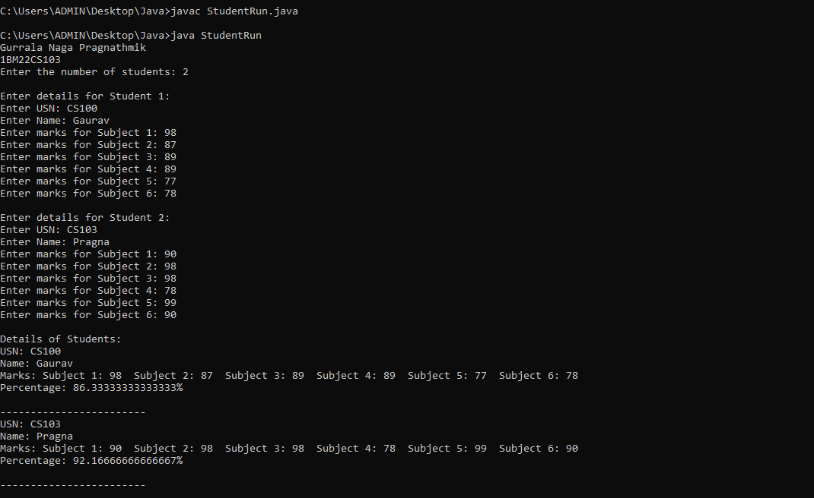

## Lab program 2

Develop a Java program that prints all real solutions to the quadratic equation ax2+bx+c = 0. Read in a, b, c and use the quadratic formula. If the discriminate b2-4ac is negative, display a message stating that there are no real solutions.

### CODE

### import java.util.Scanner;

### public class Quadratic {

### public static void main(String[] args) {

### Scanner scanner = new Scanner(System.in);

### // Input coefficients a, b, and c

### System.out.print("Enter coefficient a: ");

### double a = scanner.nextDouble();

### System.out.print("Enter coefficient b: ");

### double b = scanner.nextDouble();

### System.out.print("Enter coefficient c: ");

### double c = scanner.nextDouble();

### // Calculate the discriminant

### double discriminant = b * b - 4 * a * c;

### // Check the discriminant for roots

### if (discriminant > 0) {

### // Two distinct real roots

### double root1 = (-b + Math.sqrt(discriminant)) / (2 * a);

### double root2 = (-b - Math.sqrt(discriminant)) / (2 * a);

### System.out.println("Root 1: " + root1);

### System.out.println("Root 2: " + root2);

### } else if (discriminant == 0) {

### // One real root (double root)

### double root = -b / (2 * a);

### System.out.println("Root: " + root);

### } else {

### // Complex roots

### double realPart = -b / (2 * a);

### double imaginaryPart = Math.sqrt(-discriminant) / (2 * a);

### System.out.println("Root 1: " + realPart + " + " + imaginaryPart + "i");

### System.out.println("Root 2: " + realPart + " - " + imaginaryPart + "i");

### }

### }

### }

### OUTPUT

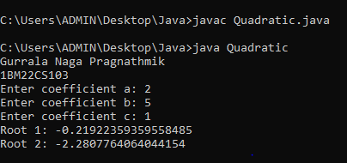

### Lab program 3

Create a class Book which contains four members: name, author, price, num_pages. Include a constructor to set the values for the members. Include methods to set and get the details of the objects. Include a toString( ) method that could display the complete details of the book. Develop a Java program to create n book objects

### import java.util.Scanner;

### class Books {

### String Name;

### String Author;

### int price;

### int numPages;

### Books(String Name, String Author, int price, int numPages) {

### this.Name = Name;

### this.Author = Author;

### this.numPages = numPages;

### this.price = price;

### }

### public String toString() {

### String name, author, price, numPages;

### name = "Book name: " + this.Name + "\n";

### author = "Author name: " + this.Author + "\n";

### numPages = "Number of pages: " + this.numPages + "\n";

### price = "Price: " + this.price + "\n";

### return name + author + numPages + price;

### }

### }

### class BooksRun {

### public static void main(String[] args) {

### Scanner s = new Scanner(System.in);

### int n;

### String Name;

### String Author;

### int price;

### int numPages;

### System.out.print("Enter the number of books: ");

### n = s.nextInt();

### Books b[] = new Books[n];

### for (int i = 0; i < n; i++) {

### System.out.println(" ");

### System.out.print("Enter name of book: ");

### Name = s.next();

### System.out.print("Enter name of Author: ");

### Author = s.next();

### System.out.print("Enter price: ");

### price = s.nextInt();

### System.out.print("Enter numPages: ");

### numPages = s.nextInt();

### b[i] = new Books(Name, Author, price, numPages);

### }

### for (int i = 0; i < n; i++) {

### System.out.println("\nBook" + (i + 1));

### System.out.println(b[i].toString());

### }

### }

### }

**Output:**

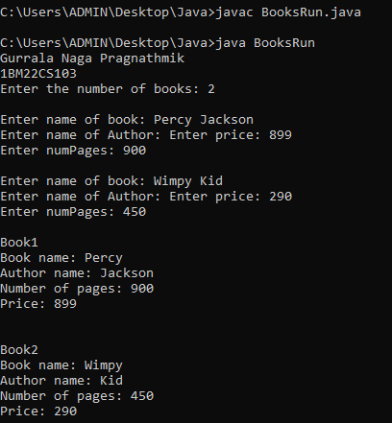

## Lab program 4

Develop a Java program to create an abstract class named Shape that contains two integers and an empty method named printArea( ). Provide three classes named Rectangle, Triangle and Circle such that each one of the classes extends the class Shape. Each one of the classes contain only the method printArea( ) that prints the area of the given shape

### import java.util.Scanner;

### abstract class Shape {

### protected int dimension1;

### protected int dimension2;

### public Shape(int dimension1, int dimension2) {

### this.dimension1 = dimension1;

### this.dimension2 = dimension2;

### }

### public abstract void printArea();

### }

### class Rectangle extends Shape {

### public Rectangle(int length, int width) {

### super(length, width);

### }

### public void printArea() {

### int area = dimension1 * dimension2;

### System.out.println("Area of Rectangle: " + area);

### }

### }

### class Triangle extends Shape {

### public Triangle(int base, int height) {

### super(base, height);

### }

### public void printArea() {

### double area = 0.5 * dimension1 * dimension2;

### System.out.println("Area of Triangle: " + area);

### }

### }

### class Circle extends Shape {

### public Circle(int radius) {

### super(radius, 0); // Only one dimension (radius) needed for a circle

### }

### public void printArea() {

### double area = Math.PI * dimension1 * dimension1;

### System.out.println("Area of Circle: " + area);

### }

### }

### public class Main {

### public static void main(String[] args) {

### Rectangle rectangle = new Rectangle(4, 5);

### rectangle.printArea();

### Triangle triangle = new Triangle(3, 6);

### triangle.printArea();

### Circle circle = new Circle(7);

### circle.printArea();

### }

### }

### OUTPUT

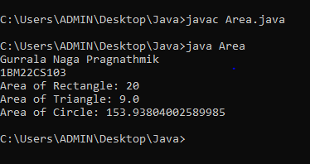

## Lab program 5

Develop a Java program to create a class Bank that maintains two kinds of account for its customers, one called savings account and the other current account. The savings account provides compound interest and withdrawal facilities but no cheque book facility. The current account provides cheque book facility but no interest. Current account holders should also maintain a minimum balance and if the balance falls below this level, a service charge is imposed. Create a class Account that stores customer name, account number and type of account. From this derive the classes Cur-acct and Sav-acct to make them more specific to their requirements. Include the necessary methods in order to achieve the following tasks: a) Accept deposit from customer and update the balance. b) Display the balance. c) Compute and deposit interest d) Permit withdrawal and update the balance Check for the minimum balance, impose penalty if necessary and update the balance.

### CODE

### import java.util.Scanner;

### public class Bank {

### public static void main(String[] args) {

### Scanner scanner = new Scanner(System.in);

### System.out.println("Welcome to the Bank!");

### System.out.print("Enter name for Account (Savings/Current): ");

### String savingsAccountName = scanner.nextLine();

### String currentAccountName = savingsAccountName;

### // Get user input for Savings Account

### System.out.print("Enter account number for Savings Account: ");

### String savingsAccountNumber = scanner.nextLine();

### SavingsAccount savingsAccount = new SavingsAccount(savingsAccountName, savingsAccountNumber);

### // Get user input for Current Account

### System.out.print("Enter account number for Current Account: ");

### String currentAccountNumber = scanner.nextLine();

### CurrentAccount currentAccount = new CurrentAccount(currentAccountName, currentAccountNumber);

### // Perform operations on savings account

### System.out.println("\nPerforming operations on Savings Account:");

### System.out.print("Enter amount to deposit into Savings Account: ");

### double savingsDepositAmount = scanner.nextDouble();

### savingsAccount.deposit(savingsDepositAmount);

### savingsAccount.displayBalance();

### System.out.print("Enter amount to withdraw from Savings Account: ");

### double savingsWithdrawAmount = scanner.nextDouble();

### savingsAccount.withdraw(savingsWithdrawAmount);

### savingsAccount.displayBalance();

### // Perform operations on current account

### System.out.println("\nPerforming operations on Current Account:");

### System.out.print("Enter amount to deposit into Current Account: ");

### double currentDepositAmount = scanner.nextDouble();

### currentAccount.deposit(currentDepositAmount);

### currentAccount.displayBalance();

### System.out.print("Enter amount to withdraw from Current Account: ");

### double currentWithdrawAmount = scanner.nextDouble();

### currentAccount.withdraw(currentWithdrawAmount);

### currentAccount.displayBalance();

### scanner.close();

### }

### }

### class Account {

### protected String customerName;

### protected String accountNumber;

### protected double balance;

### public Account(String customerName, String accountNumber) {

### this.customerName = customerName;

### this.accountNumber = accountNumber;

### this.balance = 0;

### }

### public void deposit(double amount) {

### balance += amount;

### System.out.println("Deposit of $" + amount + " successful.");

### }

### public void displayBalance() {

### System.out.println("Account Number: " + accountNumber + "\nBalance: $" + balance);

### }

### }

### class SavingsAccount extends Account {

### public SavingsAccount(String customerName, String accountNumber) {

### super(customerName, accountNumber);

### }

### public void withdraw(double amount) {

### if (balance >= amount) {

### balance -= amount;

### System.out.println("Withdrawal of $" + amount + " successful.");

### } else {

### System.out.println("Insufficient funds for withdrawal.");

### }

### }

### }

### class CurrentAccount extends Account {

### private double minimumBalance = 1000; // Assuming a minimum balance requirement

### public CurrentAccount(String customerName, String accountNumber) {

### super(customerName, accountNumber);

### }

### public void withdraw(double amount) {

### if (balance - amount >= minimumBalance) {

### balance -= amount;

### System.out.println("Withdrawal of $" + amount + " successful.");

### } else {

### System.out.println("Insufficient funds. Service charge applied.");

### imposeServiceCharge();

### }

### }

### private void imposeServiceCharge() {

### double serviceCharge = 20; // Assuming a service charge of $20

### balance -= serviceCharge;

### System.out.println("Service charge of $" + serviceCharge + " imposed.");

### }

### }

### OUTPUT

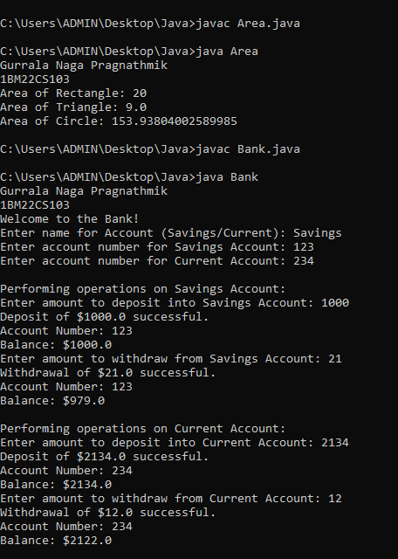

## Lab program 6

Create a package CIE which has two classes- Student and Internals. The class Personal has members like usn, name, sem. The class internals has an array that stores the internal marks scored in five courses of the current semester of the student. Create another package SEE which has the class External which is a derived class of Student.This class has an array that stores the SEE marks scored in five courses of the current semester of the student. Import the two packages in a file that declares the final marks of n students in all five courses.

### CODE

### package CIE;

### public class student

### {

### public String usn,name;

### public int sem;

### public student(String usn,String name,int sem)

### {this.usn=usn;

### this.name=name;

### this.sem=sem;

### }

### }

### package CIE;

### public class Internals extends student

### {

### public int m[]=new int[5];

### public Internals(String usn,String name,int sem,int[] m)

### {super(usn,name,sem);

### this.m=m;

### }

### } package SEE;

### import CIE.student;

### public class Externals extends student

### {

### public int sm[]=new int[5];

### public Externals(String usn,String name,int sem,int[] sm)

### {super(usn,name,sem);

### this.sm=sm;

### }

### } import java.util.*;

### import CIE.student;

### import CIE.Internals;

### import SEE.*;

### public class Main

### {

### public static void main(String args[])

### {

### int fm=0;

### Scanner in=new Scanner(System.in);

### System.out.print("Enter no. of students: ");

### int n=in.nextInt();

### Internals []im=new Internals[n];

### Externals []em=new Externals[n];

### student []stu=new student[n];

### for(int i=0;i<n;i++)

### {

### System.out.print("\nEnter details of student "+(i+1)+": ");

### System.out.print("\nEnter name: ");

### in.nextLine();

### String name=in.nextLine();

### System.out.print("Enter usn: ");

### String usn=in.nextLine();

### System.out.print("Enter semester: ");

### int sem=in.nextInt();

### int []imarks=new int[5];

### int []emarks=new int[5];

### System.out.print("Enter marks details: ");

### for(int j=0;j<5;j++)

### {

### System.out.print("Enter internal marks for course"+(j+1)+": ");

### imarks[j]=in.nextInt();

### System.out.print("Enter see marks for course"+(j+1)+": ");

### emarks[j]=in.nextInt();

### }

### stu[i]=new student(usn,name,sem);

### im[i]=new Internals(usn,name,sem,imarks);

### em[i]=new Externals(usn,name,sem,emarks);

### }

### System.out.print("Final marks details: ");

### for(int i=0;i<n;i++)

### {

### System.out.println("Student"+(i+1)+": ");

### System.out.println("Name: "+stu[i].name);

### System.out.println("USN: "+stu[i].usn);

### System.out.println("Semester: "+stu[i].sem);

### for(int j=0;j<5;j++)

### {

### fm+=im[i].m[j]+em[i].sm[j];

### System.out.println("Final marks of course"+(j+1)+":"+fm);

### fm=0;

### }

### System.out.println();

### }

### }

### }

### OUTPUT

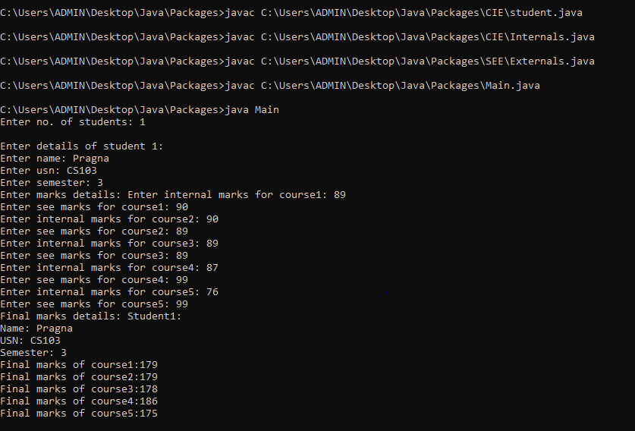

## Lab program 7

Write a program that demonstrates handling of exceptions in inheritance tree. Create a base class called “Father” and derived class called “Son” which extends the base class. In Father class, implement a constructor which takes the age and throws the exception WrongAge( ) when the input age<0. In Son class, implement a constructor that cases both father and son’s age and throws an exception if son’s age is >=father’s age.

### CODE

### class WrongAge extends Exception {

### public WrongAge(String message) {

### super(message);

### }

### }

### class Father {

### int age;

### public Father(int age) throws WrongAge {

### if (age < 0) {

### throw new WrongAge("Age cannot be negative");

### }

### this.age = age;

### }

### public int getAge() {

### return age;

### }

### }

### class Son extends Father { int sonAge;

### public Son(int fatherAge, int sonAge) throws WrongAge { super(fatherAge); if (sonAge >= fatherAge) {

### throw new WrongAge("Son's age cannot be greater than or equal to father's age");

### }

### this.sonAge = sonAge;

### }

### public int getSonAge() {

### return sonAge;

### }

### }

### public class checkAge { public static void main(String[] args) { System.out.println("Pragna 1BM22CS103"); try {

### Father father = new Father(45);

### System.out.println("Father's age: " + father.getAge());

### Son son = new Son(45, 65);

### System.out.println("Son's age: " + son.getSonAge());

### } catch (WrongAge e) {

### System.out.println("Exception caught: " + e.getMessage());

### }

### }

### }

### OUTPUT

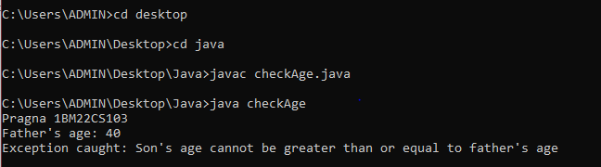

## Lab program 8

Write a program which creates two threads, one thread displaying “BMS College of

Engineering” once every ten seconds and another displaying “CSE” once every two seconds.

### CODE

### class display implements Runnable

### {

### String message;

### int interval;

### public display(String message, int interval)

### {this.message=message;

### this.interval=interval;

### }

### @Override

### public void run()

### {try

### {while(true)

### {System.out.println(message);

### Thread.sleep(interval);

### }

### }

### catch(InterruptedException e)

### {

### System.out.println(e);

### }

### }

### }

### class displayrun

### {

### public static void main(String args[])

### {

### Thread t1=new Thread (new display("BMSCE",10000));

### t1.start();

### Thread t2=new Thread(new display("CSE",2000));

### t2.start();

### }

### }

### OUTPUT

